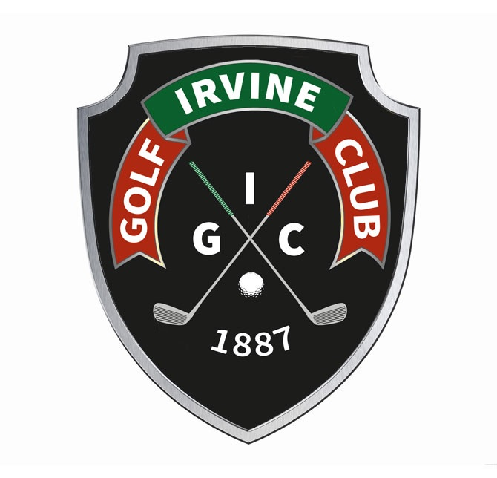
(LADIES' SECTION)
OPEN DAY TRI-AM

MONDAY 1st JULY 2019

ENTRY FORM

First Player: Second Player:

Name: …………………………………… Name: …………………………………..

Address: …………………………………… Club: …………………………………..

…………………………………… Handicap: ……
CDH No: …………………………..
Third Player: (Optional)

Tel: …………………………………… Name: …………………………………..

Club: …………………………………… Club: …………………………………..

Handicap: …… CDH NO: ………………… Handicap: …… CDH NO: ………………..

Please enclose cheque (payable to The Irvine Golf Club
Ladies' Section) for £10.00 per person and
forward with completed form and a stamped,
self-addressed envelope to:

Preferred tee-off time ………. am/ ……….. pm

The Ladies' Secretary
(Open Tri-Am Competition)
The Irvine Golf Club
Bogside IRVINE
KA12 8SN

-------------------------------------------------------------------------------------------------------------------------------------
THE IRVINE GOLF CLUB (LADIES' SECTION)
OPEN DAY TRI-AM
MONDAY 1st JULY 2019

Names: ……………………………………………………………………………………………..............

Thank you for your entry to our Open Day. Your starting time is: ……………………..

Entry Form now available from www.theirvinegolfclub.co.uk

